

CSA0501-DATABASE MANAGEMENT SYSTEMS

LAB EXPERIMENTS DATE: 29/07/2026

EXPERIMENT 14 – TCL COMMANDS – COMMIT, SAVEPOINT, ROLLBACK

AIM: To learn how to use various TCL commands Commit, Savepoint and Rollback SQL commands.
PROCEDURE:
- Transaction Control Language (TCL) commands are used to manage transactions in the database. These are used
- to manage the changes made to the data in a table by DML statements. It also allows statements to be grouped
- together into logical transactions.
- This command restores the database to last committed state.
- ➢ It is also used with SAVEPOINT command to jump to a savepoint in an ongoing transaction.
- ➢ If we have used the UPDATE command to make some changes into the database, and realize that those
- changes were not required, then we can use the ROLLBACK command to rollback those changes, if they
- were not committed using the COMMIT command.

PROGRAM:

Create the milka_dairy table and insert the given records. Use SAVEPOINT commands between the insert operations. Roll back to different savepoints and use SELECT commands to verify the changes.

Desc milka_dairy

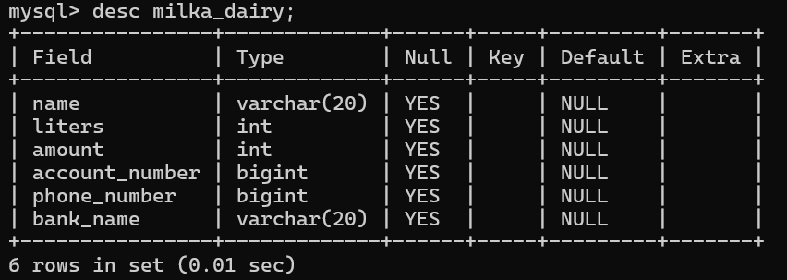

1. Start Transaction

START TRANSACTION;

2. Insert first record

INSERT INTO milka_dairy

(name, liters, amount, account_number, phone_number, bank_name)

VALUES

('Shanthi', 5, 320, 9679411723, 8639516519, 'SBI');

SAVEPOINT sp1;

SELECT * FROM milka_dairy;

OUTPUT:

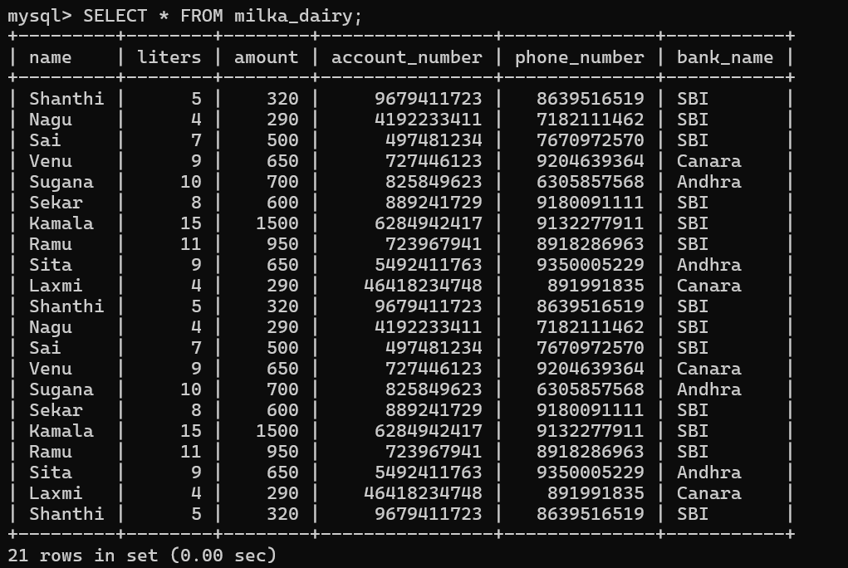

3. Insert second record
INSERT INTO milka_dairy
(name, liters, amount, account_number, phone_number, bank_name)
VALUES
('Nagu', 4, 290, 4192233411, 7182111462, 'SBI');

SAVEPOINT sp2;
Check:
SELECT * FROM milka_dairy;

OUTPUT:

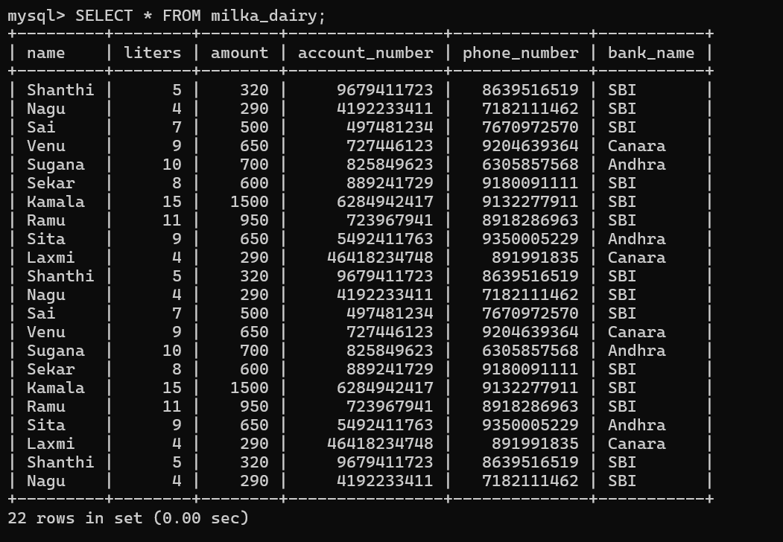

4. Insert third record
INSERT INTO milka_dairy
(name, liters, amount, account_number, phone_number, bank_name)
VALUES
('Sai', 7, 500, 497481234, 7670972570, 'SBI');

SAVEPOINT sp3;
Check:
SELECT * FROM milka_dairy;
OUTPUT:
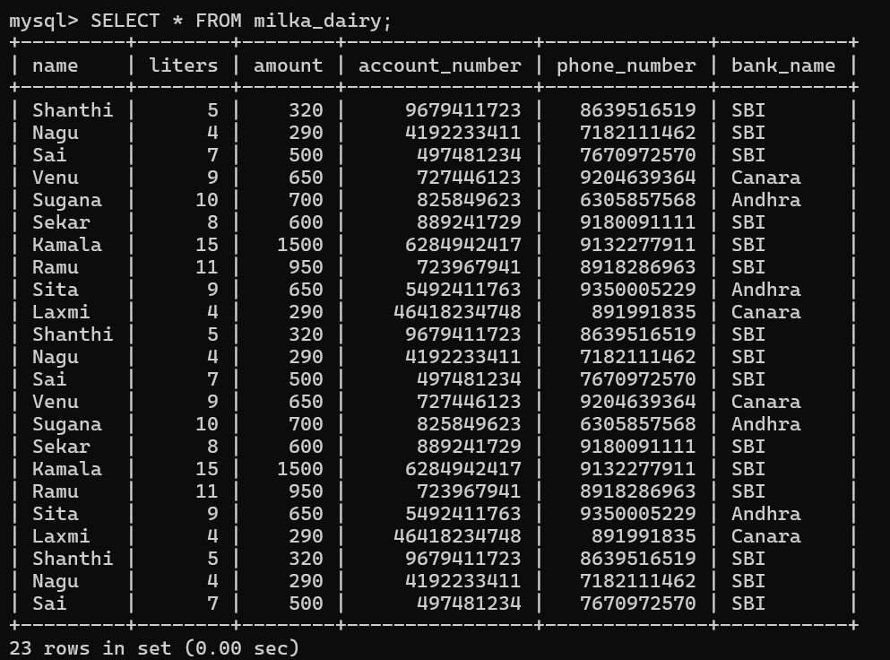

5. Insert fourth record
INSERT INTO milka_dairy
(name, liters, amount, account_number, phone_number, bank_name)
VALUES
('Venu', 9, 650, 727446123, 9204639364, 'Canara');

SAVEPOINT sp4;
Check:
SELECT * FROM milka_dairy;

OUTPUT:
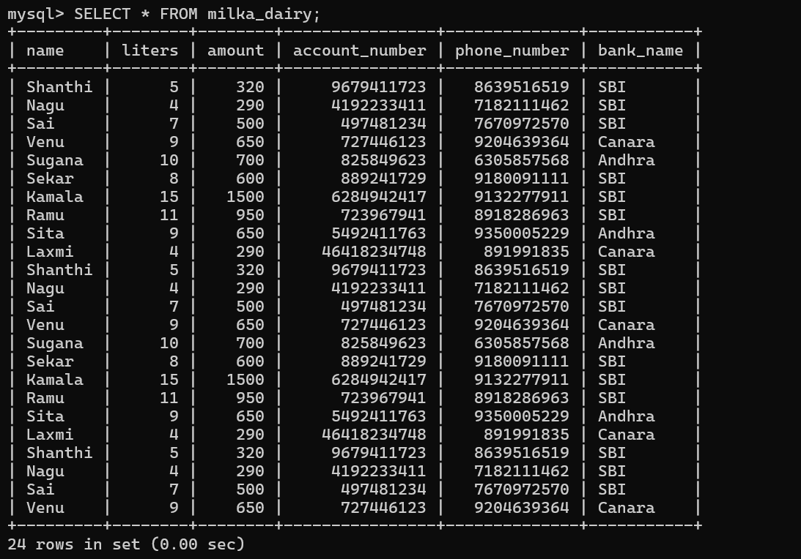

6. Rollback to sp2
Now the Sai and Venu records will be removed from the current transaction.
ROLLBACK TO SAVEPOINT sp2;
Check the result:
SELECT * FROM milka_dairy;

OUTPUT:

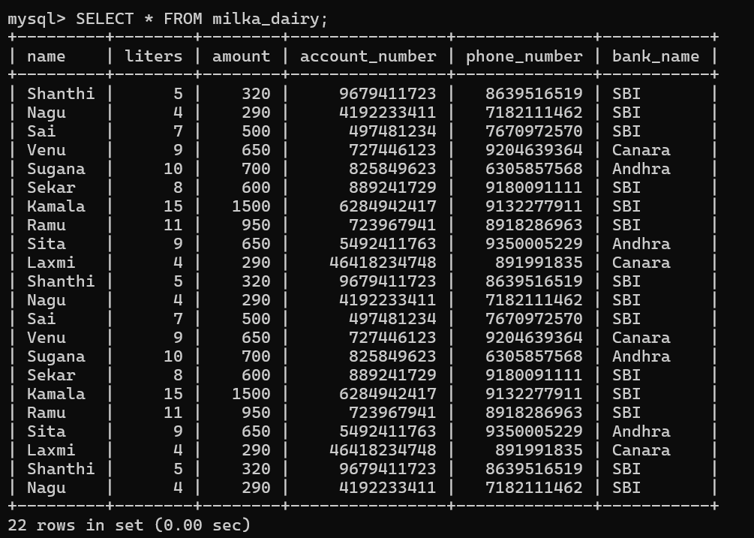

7. Continue inserting after rollback
INSERT INTO milka_dairy
(name, liters, amount, account_number, phone_number, bank_name)
VALUES
('Sugana', 10, 700, 825849623, 6305857568, 'Andhra');

SAVEPOINT sp5;
Check:
SELECT * FROM milka_dairy;

OUTPUT:
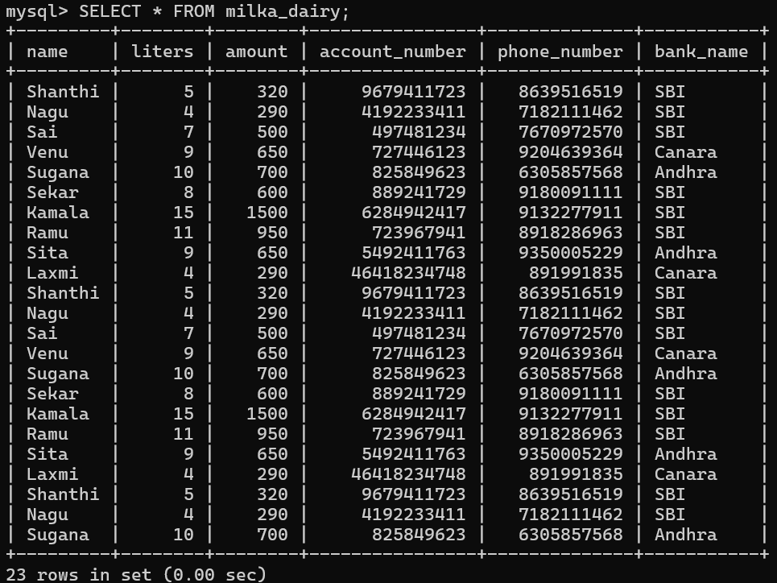

8. Commit the transaction
COMMIT;
Check:
SELECT * FROM milka_dairy;

OUTPUT:

